

**CS-TS**

**Air source heat pump temperature sensor**

（Product Specification）

XI'AN CHINASTAR M&C LIMITED

**To Be An Influential And Innovative Enterprise In Global Sensor Field**

# Revision History

|  |  |  |  |
| --- | --- | --- | --- |
| Date | Rev | Revision Contents | Reviser |
| 2025.02.20 | A | First Release | ZhaoWei |
|  | B |  |  |
|  | C |  |  |
|  | D |  |  |
|  | E |  |  |
|  | F |  |  |
|  | G |  |  |
|  | H |  |  |
|  | I |  |  |
|  | J |  |  |
|  | K |  |  |
|  |  |  |  |
|  |  |  |  |
|  |  |  |  |
|  |  |  |  |
|  |  |  |  |

Note: The revised resume on this page is for internal viewing only.

# CS-TS

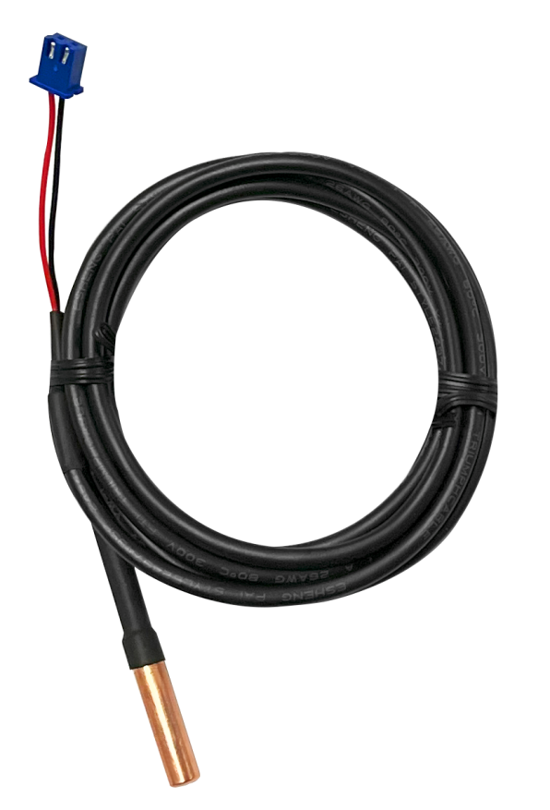

**Description**

The CS-TS temperature sensor, which employs an NTC (Negative Temperature Coefficient) the rmistor as its sensitive element, is a pivotal component for monitoring and controlling the temperature within air-source heat pump systems. It is designed to collect real-time temperature data from key components of the heat pump system, including the evaporator, condenser, compressor, fan coil, as well as the ambient temperature, thereby ensuring the system operates safely, efficiently, and stably. Characterized by high precision, rapid response, and low cost, the CS-TS temperature sensor stands as an ideal choice for temperature monitoring in heat pump systems.

# Applications

● Evaporator Temperature Monitoring: Prevents frost formation or overheating.

● Condenser Temperature Monitoring: Ensures efficient heat exchange in the condenser.

● Compressor Discharge Temperature Monitoring: Protects the compressor from overheating.

● Fan Coil Temperature Monitoring: Regulates fan speed and monitors coil temperature.

● Ambient Temperature Monitoring:

Adjusts operating modes based on environmental conditions

# Features

● High Accuracy

● Fast Response

● Excellent Stability

● Cost-Effective and Easy to Install

● Low Power Consumption

**Performance Specifications**

Temperature：25±0.01℃；Relative humidity：45%～75%；ambient atmospheric pressure：86KPa～106KPa;

|  |  |
| --- | --- |
| **Sensor type** | NTC R25=5KΩ±1% , |
| **Zero power resistance** | R25=5KΩ±1% , |
| **B value** | B25/50=3470K±1% |
| **Dissipation coefficient** | 0.9 mW /℃ |
| **Maximum rated power** | 35mW |
| **Sensitive Element Encapsulation** | Single-ended Glass Encapsulation |
| **Operating Temperature** | -30℃～80℃ |
| **Storage Temperature** | -40℃～80℃ |
| **Storage humidity** | 0%～95% RH (Non-condensing) |
| **Operating humidity** | 0%～95% RH (Non-condensing) |
| **Insulate Resistance** | ≥100MΩ@50VDC |
| **IP Rating** | IP67 |
| **Random Vibration** | 10g，5～2000Hz |
| **Shock** | X/Y/Z, 20g, half-sine 11ms |
| **Drop (any Axis)** | 1m |
| **Immersion tube material** | Copper |
| **Immersion Tube Dimensions** | φ5×25 |
| **Electrical Connection** | XH-2Y (Blue) |

**Structure and Dimension (mm)**

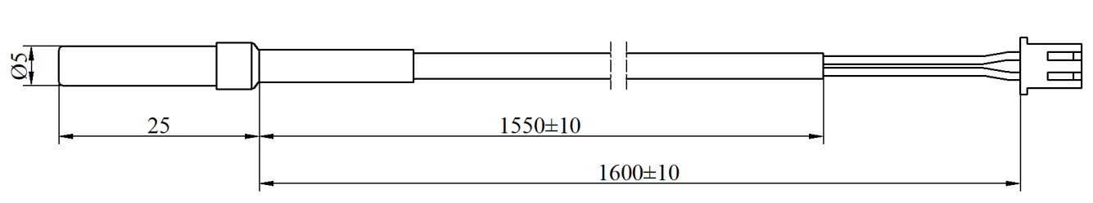

**Electrical Connection**

|  |  |  |
| --- | --- | --- |
| XH-2Y | PIN | Color of Wire |
|  | PIN1 | Red |
| PIN2 | Black |

**Notes**

1. It is strictly prohibited to open the sensor for repair by oneself.
2. If you are unsure whether the sensor is suitable for the measurement environment in use, please contact the manufacturer.
3. The installation position of the sensor should be chosen in a place where it is not easily collided with or stepped on.
4. Using the sensor beyond its allowable temperature range may cause permanent damage.
5. In situations where lightning may occur, customers should consider lightning protection measures.

**Disposal methods of hazardous wastes such as waste circuit boards and their components after**

**the end of product life.**

After the end of the product life, each part shall be distinguished according to the “National

hazardous waste list” to determine whether it is hazardous waste. Among them, the waste lithium battery not disassembled is not hazardous waste, and the waste circuit board (including components, chips, plug-ins, pins, etc. attached to the waste circuit board) belongs to hazardous waste.

The part that is not hazardous waste shall be treated as general industrial solid waste, and the lithium battery shall be handed over to the nearby renewable resource recovery department or sent to the product manufacturer for recycling.

Hazardous wastes must be handed over to legally qualified departments for disposal in

accordance with national regulations, and shall not be dumped or stacked without authorization.If it is really necessary to store temporarily, protective measures meeting the national environmental protection standards must be taken, and the storage period shall not exceed one year. At the same time, the time and place of temporary storage and the protective measures taken shall be reported to the competent environmental protection department. Hazardous waste transfer activities can be arranged according to the actual production situation. The system shall be strictly implemented in the transfer process.

**Statement**

The company reserves the right to modify the specifications and contents of this manual. Subject to modification without notice. Due to the update of the product, the individual details of this document may not match the product, please refer to the actual product. The interpretation right of this document belongs to our company.

————————————————————————