CS-iBHT Wireless Bluetooth Temperature and Humidity Sensor
（Product Specification）

XI'AN CHINASTAR M&C LIMITED
To Be An Influential And Innovative Enterprise In Global Sensor Field

Revision History
Date | Rev | Revision Contents | Reviser
2024.12.31 | A | First Release | Hexinxin
2025.04.28 | B | Modify the product feature description | Chengang

 | Producer | Verifier | Standardization | Approver
Signature | 2025-05-06 | 2025-05-06 |  | 2025-05-06  2025-05-07
Date
Note: This page is only for internal viewing within the company.

CS-iBHT-01

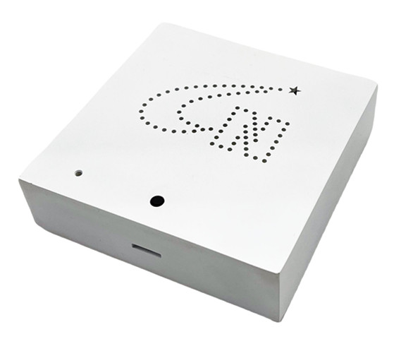
Figure#1 Product outline drawing

Description
CS-iBHT-01 Wireless Bluetooth Temperature and Humidity Transmitter can be applied to the temperature and humidity of home, office, warehouse, workshop and laboratory.Field of measurement. High precision temperature and humidity sensor and special calibration circuit are selected to realize high precision measurement of temperature and humidity.
CS-iBHT-01 wireless Bluetooth temperature and humidity transmitter has the advantages of high precision at room temperature and small temperature drift.

Applications
● Household temperature and humidity detection
● Office temperature and humidity detection
● Warehouse temperature and humidity detection
● Temperature and humidity detection in production workshop
● Laboratory temperature and humidity testing

Features
● High precision temperature and humidity sensor
● Relative humidity range: 0 ~ 95% RH
● Temperature range: 0 ℃ ~ 50 ℃
● Power supply mode: AA battery (1.5VDC) × 2
● Low power consumption, long service life
● Wall mounted

Performance Specifications
Temp: 20~25 ℃; Power: 3VDC; Humidity: 45%~75%RH; Atmospheric pressure: 86 KPa ~ 106 KPa;
Table1 Main technical parameters
Measuring range (humidity) | 0~95%RH
Measuring range (temperature) | 0℃～50℃
Normal temperature accuracy (humidity) | ± 2% RH. (@ 25 ℃, 20 ~ 80% RH, typical)
Hysteresis (humidity) | ±1.5% RH.
Normal temperature accuracy (temperature) | ±0.2℃（@25℃）
Communication mode | Bluetooth 5.1
Supply voltage | AA×2，3V DC
Communication distance | 15 m
Long-term stability (humidity) | ± 0.25% FS/year (typical)
Long-term stability (temperature) | ± 0.1% FS/year (typical)
Response time | ≤10s
Operating temperature | 0℃～50℃
Storage temperature | -20℃～60℃
Insulation resistance | ≥100MΩ@100VDC
Insulation strength | 500VDC @ 1 minute (no sparks, arcing, no damage)
Electrostatic discharge (ESD) | ± 4 kV contact discharge, ± 8 kV air discharge
Degree of protection | IP30
Shell material | Plastic
Installation method | Wall mounted

Structure and Dimension

Figure#2 Outline strcture(unit:mm)

Key And Indicator Function
- In the unconnectable state (default state), press and hold the button for 3 ~ 8 seconds, and the green and red lights will flash for 2 seconds at the same time, and the device will enter the connectable state;
- Press the button for 1-8 seconds in the connectable state, and the green light flashes for 2 seconds, indicating that the device is connected.The red light flashes for 2 seconds to indicate that the device is not connected or disconnected;
- The green light flashes for 2 seconds when the equipment is connected successfully;
- Device connection timeout red light flashes for 2 seconds;
- If the key is pressed for more than 10 seconds in any state, the equipment will be restored to the factory (broadcast interval is 3 seconds, sampling interval is 60 seconds) and restarted;

Precautions
A. The transmitter must be used in an application environment that is non-corrosive to the sealing material and housing material.
B. The transmitter shall be installed in a place where it is not easy to be bumped and trampled.
C. Use outside the operating temperature range of the transmitter may cause permanent damage.

Disposal methods of hazardous wastes such as waste circuit boards and their components after the end of product life
After the end of the product life, each part shall be distinguished according to the “National hazardous waste list” to determine whether it is hazardous waste. Among them, the waste lithium battery not disassembled is not hazardous waste, and the waste circuit board (including components, chips, plug-ins, pins, etc. attached to the waste circuit board) belongs to hazardous waste.
The part that is not hazardous waste shall be treated as general industrial solid waste, and the lithium battery shall be handed over to the nearby renewable resource recovery department or sent to the product manufacturer for recycling.
Hazardous wastes must be handed over to legally qualified departments for disposal in accordance with national regulations, and shall not be dumped or stacked without authorization. If it is really necessary to store temporarily, protective measures meeting the national environmental protection standards must be taken, and the storage period shall not exceed one year. At the same time, the time and place of temporary storage and the protective measures taken shall be reported to the competent environmental protection department. Hazardous waste transfer activities can be arranged according to the actual production situation. The system shall be strictly implemented in the transfer process

Statement
Chinastar Company. reserves the right to modify the specifications and contents of this instruction. No further notice will be given if any changes are made. Due to product updates, the individual details of this document may not match the product. Please refer to the actual product. The right to interpret this document belongs to Chinastar Company.
————————————————————————

